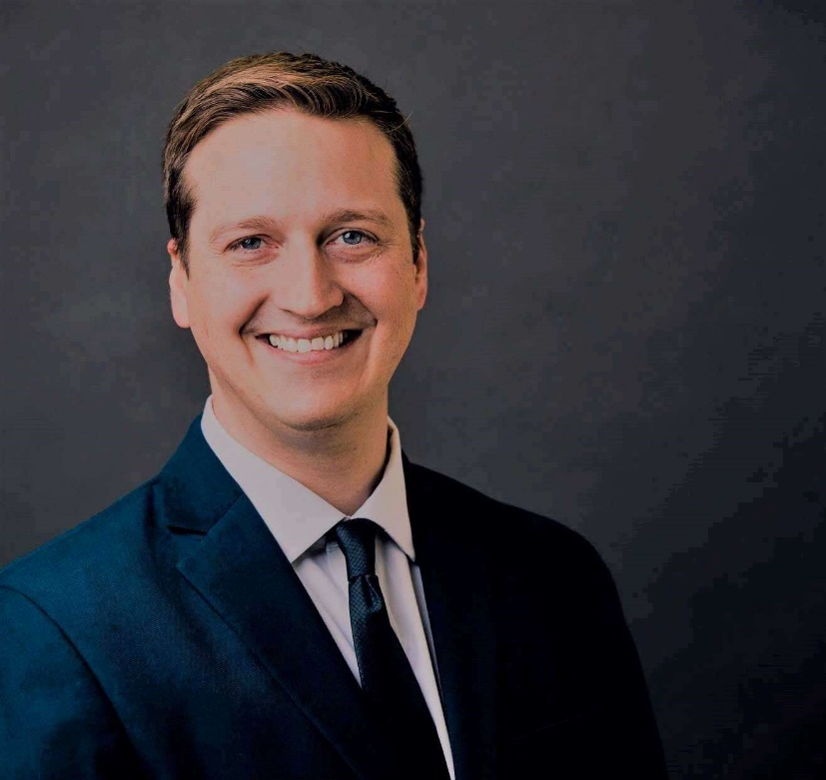

Michael D. Easton
President, General Manager
Star USA, Inc.
201 E. Liberty St, Ste 202
Wooster, OH 44691
Ph: 330.804.0061
mdeaston@starusa.org
starusa.org

Michael is a Licensed Customs Broker, President & General Manager of Star USA, Inc. He works in the areas of Import Compliance, Export Controls, Supply Chain Security, and International Trade & Supply Chain Management.

Michael guest lectures at various institutions in and around Ohio, including Case Western Reserve University School of Law, the Ohio State University, Youngstown State University, Cleveland Freight Association, Northwest Commission, and many others.

Star USA is a trade compliance consulting, advice, and training firm. We provide a unique brand of positivity and cooperation as the foundation of the region’s leading trade compliance and education firm. We aim to create a culture of success through collaboration for our partners and clients.

